Chapter 5, Problem 69

Repeat the previous problem if R_{f} = 10 kΩ.

Chapter 5, Problem 69.

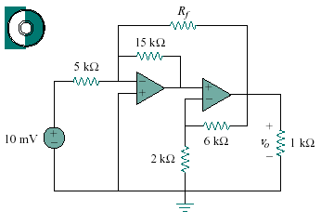
Find v_{o} in the circuit in Fig. 5.93, assuming that R_{f} = ∞ (open circuit).
15 mV

Figure 5.93
For Prob. 5.68 and 5.69.

